|  |  |
| --- | --- |
| School of Computing  Teesside University |  |

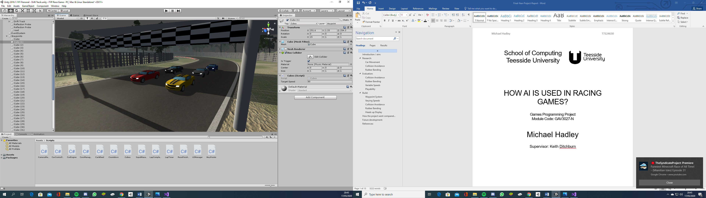

HOW AI IS USED IN RACING GAMES?

Games Programming Project

Module Code: GAV3027-N

Michael Hadley

Supervisor: Keith Ditchburn

Contents

Introduction / aim: 3

Research: 4

Car Movement 4

Collision Avoidance 5

Rubber Banding 6

Evaluation: 7

Collision Avoidance 7

Rubber Banding 7

Variable Speeds 7

Playability 8

Build: 9

Waypoint System 9

Varying Speeds 11

Collision Avoidance 12

Rubber Banding 13

Heads up Display 13

How the project went compared to the proposal: 14

Future development: 14

References: 15

## Introduction / aim:

The aim of the project was to show how AI is used within the racing games to allow a player to compete against AI controlled cars. This was done by implementing five key components:

1. Ability to follow the course and return to the desired path from any location.
2. Ability to use varying speeds for corners and straights.
3. A collision avoidance system.
4. A rubber banding to keep the AI cars near the player.
5. Allow different performance levels for each AI car.

The idea of these key components was to investigate how the AI helps with the gameplay. The first two components are the basics of the game, having a group of cars that can go around the track, with the important part being that this can be done from any location. Unlike a Scaelectics set where the cars are on a fixed groove, the AI cars can be anywhere on the course and will find the best path to the main route.

Point 3, collision avoidance is then layered on that to avoid all of the cars heading for the same single path and jostle for the best position. It also means that if you stop your car in the middle of the track, then they will “see” the obstacle and drive around it on the best side.

Item 4 is the concept of “Rubber Banding”. This is a gaming term used to keep the player and AI cars near each other, this helps to improve the gameplay. If you crash your car and lose time getting back on the track you do not want to find that the AI cars have already finished the race.

The final item allows different performance to be observed, some cars will be quicker to accelerate but go into corners too fast and lose time, while others will be slower on straights but better on corners. The code however needs to be the same with one class to rule them all.

## Research:

### Car Movement

There are a number of ways to move a car around a track. In many previous games this has involved updating the position and the rotation to give a sense of movement. This is great for a space invaders style of game, but for a driving simulation we would want to see the wheels go around in line with the speed and the direction should be controlled by both the direction of the front wheels and the grip of the back wheels (e.g. skidding around corners). To achieve this I researched wheel colliders. Wheel colliders have rotations applied to them and depending on the mass of the car, the size of the wheel and the amount of grip they will move the car in the appropriate way mimicking how a car would move in real life.

When researching the wheel colliders I found that there was a page on the official Unity website[1] and that this included the correct settings for the wheel colliders, so this should have meant a simple implementation.

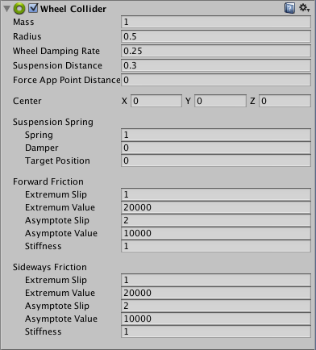[2]

However when these values were implemented didn’t work, resulting in the car flying completely off the map. Because of this I researched a number of other websites and Unity forums for correct settings, finding and trying many different values, all of which failed to work in different ways. I then found that there were a number of forums where the posts referenced that there was not one correct set of values, but that it would be different for every game, needing to use trial and error to find something that was reasonable then an iterative process of smaller adjustments to find settings that worked as expected. Below are a number of comments that I found:

“[3]Unfortunately the wheel Collider is poor and bugged and lots of problems”

“[4]Unfortunately, we have to find the correct value of the wheel until the desired behaviour...

To be honest the wheel collider is not very favorable.”

“[5]I am seeing extreme negative values coming back (every now and then) even when the wheel is rolling forward… It is unusable and needs reingeenering”

By trying different settings I was able to get to a point where the wheels would turn and provide limited grip, then improve this with the key change being to make the rear wheels heavier than the front driven wheels. Below are the final settings used for the cars:

Front wheels: Rear wheels:

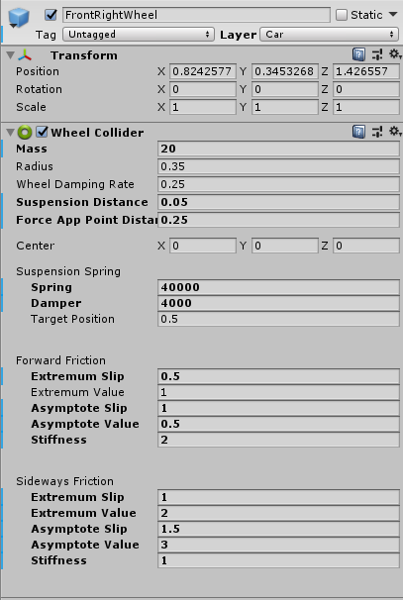 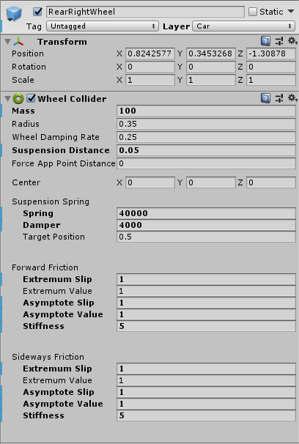

The alternative to this approach would have been to create my own wheel colliders with their own physics code which would have been a lot of work and a different project altogether.

### Collision Avoidance

To achieve collision avoidance I needed as system that could detect other objects in front of the cars and to the sides. For the detection to the front the car needs to look across the full width of the car, for the detection at the side it was simply a single line of sight that was needed. Because of this I researched various forms of “cast” functions with Raycast and Spherecast being the two most suitable versions.

The Unity documentation explains the difference between the two types of cast that I used in the collision avoidance:

[6]Both Raycast and Spherecast return a boolean but they are used for different kinds of hit detection. Spherecast casts a sphere along a ray and returns detailed information on what was hit. This is useful when a Raycast does not give enough precision, because you want to find out if an object of a specific size, such as a character, will be able to move somewhere without colliding with anything on the way. Think of the sphere cast like a thick raycast. In this case the ray is specified by a start vector and a direction.

### Rubber Banding

When looking into the implementation of AI in racing games I wanted to include Rubber Banding. In nearly all situations the aim is to replicate what would happen in real life, so if one object hits another it will bounce off it, and if a car goes around a corner too fast then it will skid and lose control, but rubber banding is different.

“[7]Rubber band AI refers to a feature of artificial intelligence found in racing titles that is designed to prevent players from getting too far ahead of computer-controlled opponents. When done well, such AIs can maintain a consistent level of challenge from the beginning of an event to the end.”

## Evaluation:

There were a number of items in the aim which have been met. The waypoint system works well to allow the AI cars to follow a path without being rigid in the exact route around the course. The waypoint system also allows different target speeds to be set on each part of the track allowing cars to slow at the corners. The system is very flexible in that it can be adapted to different track layouts (not done as part of the project but flexibility for the future) and it allows additional cubes to be add for more precision, which is something that was done as part of the development.

### Collision Avoidance

The collision avoidance system is good, using different methods for detection of obstacles in front and to the sides, using appropriate techniques for the different situations. It doesn’t detect items behind or at the side of the rear of the car, reflecting real-life driving where the driver would not consider these to be threats, which is good. The one bit that could be improved is the assessment of the speed of the nearby cars, where it does not consider the difference in speeds. For example at the very start of the race when the cars are about to move the cars on the second row take action to avoid the cars on the front row even though neither car has started and they begin to accelerate at the same time.

### Rubber Banding

The rubber banding was implemented to prevent the player or AI cars getting too far ahead of each other and this worked, meeting the requirements of the brief. From a playability view point the activation sometimes seemed late and when it was activated it was very strong. This could be adjusted simply by amending the number of cubes ahead before activating or putting the cubes closer to each other, and the strength could be easily adjusted by changing the reduction amount. The rubber banding could have been improved from a technical view point by adding increases in speed as well as the reduction that was implemented, however just increasing the speed would not have worked as the cars lose control if they go too fast which is why the solution was limited to the speed reduction.

### Variable Speeds

By using variables in the AI class, the specifications of each of the AI cars was allowed to be different while at the same time having a single class to control them all. The variation in performance is most noticeable when the player car interacts with the AI cars. Where a fast AI car is blocked by the player then released the fast AI car can be seen to overtake the slower AI car, which clearly demonstrates the implementation of different performance levels.

|  |
| --- |
| Yellow AI overtaking gray AI |

### Playability

Although it was not an aim of the project the game needs to be enjoyable. I believe that the game was fun to play and with the addition of features like countdown at the start, the position table and optional camera angles this gave the game a more polished finish. The technical aspects are good but as a game it needs the user interaction also to be good which this achieves.

## Build:

### Waypoint System

In order to give the AI cars a path to follow a waypoint system was created. This was a series of non-displayed cubes which the cars would head towards, switching to the next cube once they had reached the current cube. This allowed the cars to get back onto the track if they were to come off the track at any point.

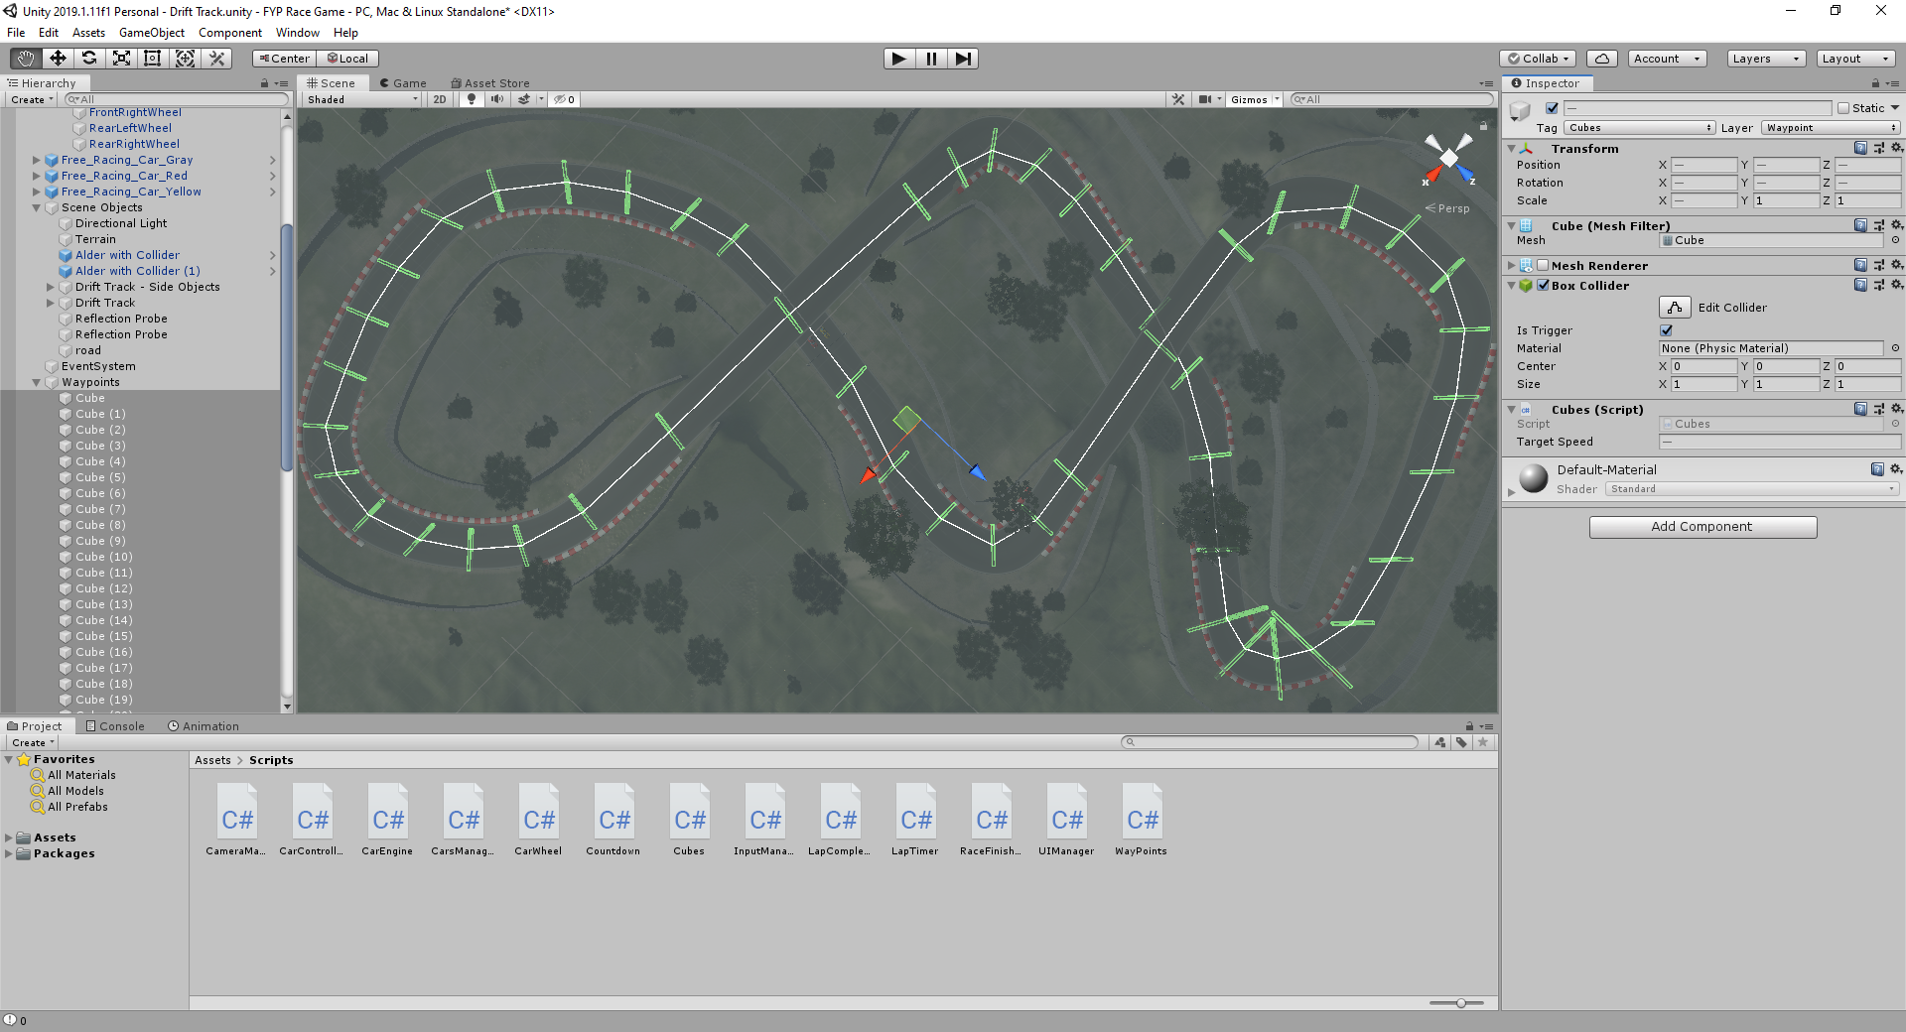

The original waypoint cubes where increased in length during testing as I found that if the AI cars went wide of the waypoint they would U-Turn to go back to the waypoint. As well as checking if the car was near the centre of the cube the cars also checked if they were close to the vertices of the cube, this prevented the car from missing the waypoint.

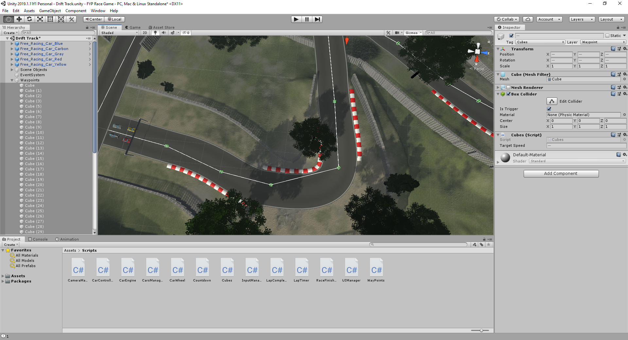

Run off missing waypoint

Above is original waypoint layout where cars could miss waypoint.

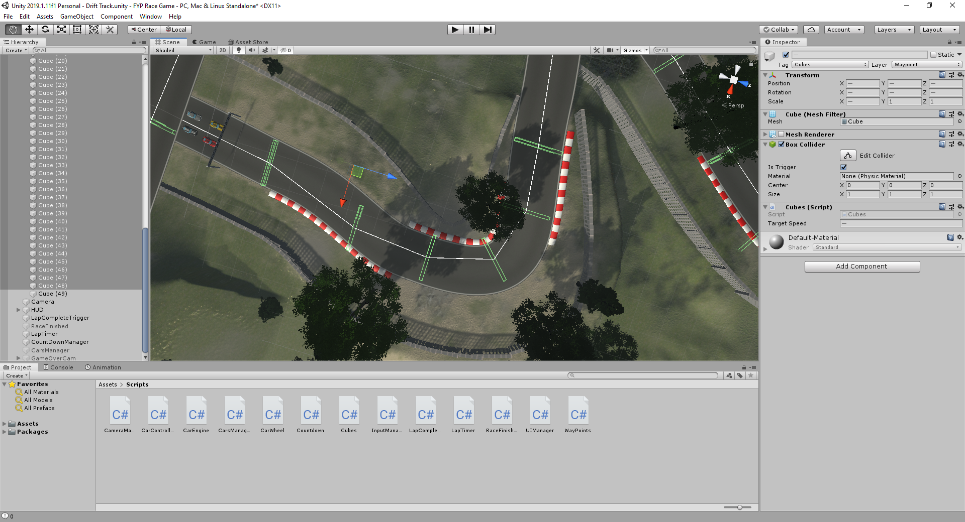

Run off catches waypoint

Above shows longer cubes with detection on vertices.

With the new sized cubes and the implementation of a vertices checker, the next improvement was to add more waypoints making the path of the AI a lot smoother.

The cubes in the waypoint system are used to ensure laps are completed correctly and calculate the car’s position in the race. These can all be viewed in the inspector.

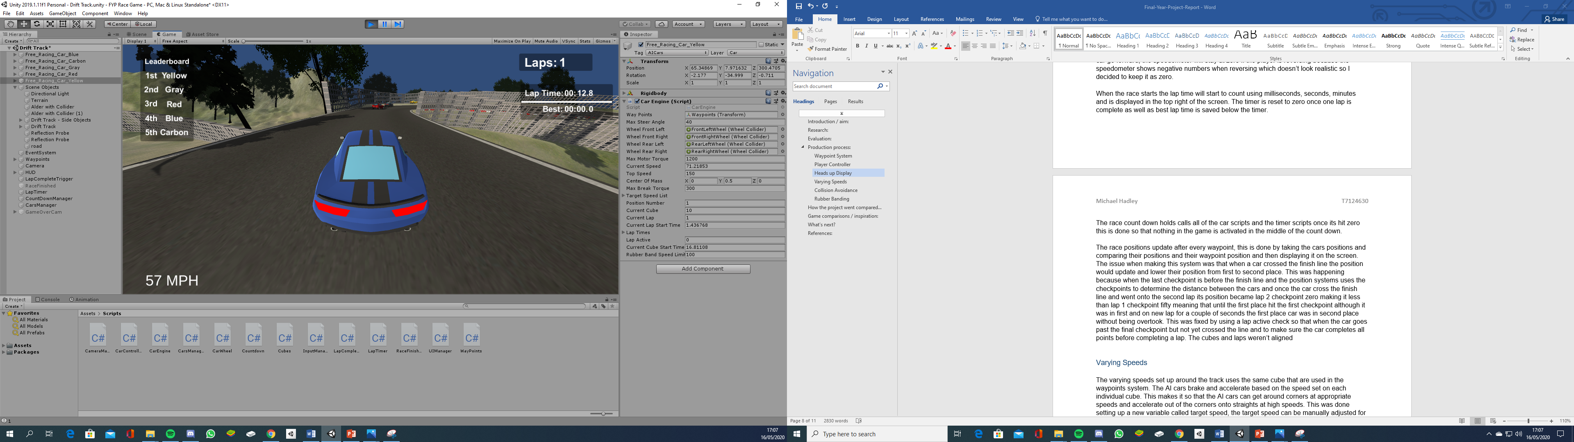

To complete a lap the car must pass each cube in order, and only when passing the final cube will the car be able to complete a lap (so the player can not just go back and forth over the start/finish line).

The race positions update after every waypoint change, this is done by taking the car’s location and comparing it to the locations of the other cars and then displaying it on the screen. The issue when making this system was that the location was based on the current lap and current cube. The detection of the cube is based on proximity to the centre or vertices of the cube, but for start/finish line it is the car actually touching it, so the cubes and laps weren’t aligned. When the car approaches the final cube the current cube is changed to cube zero, but the car is still on the same lap (so it looks like it has gone back to the start of the lap). This was fixed by using the lap active variable so that when the car goes past the final waypoint but has not yet crossed the line, the calculation treats this as if it was at the start of the next lap.

Final waypoint to finish line caused position issues.

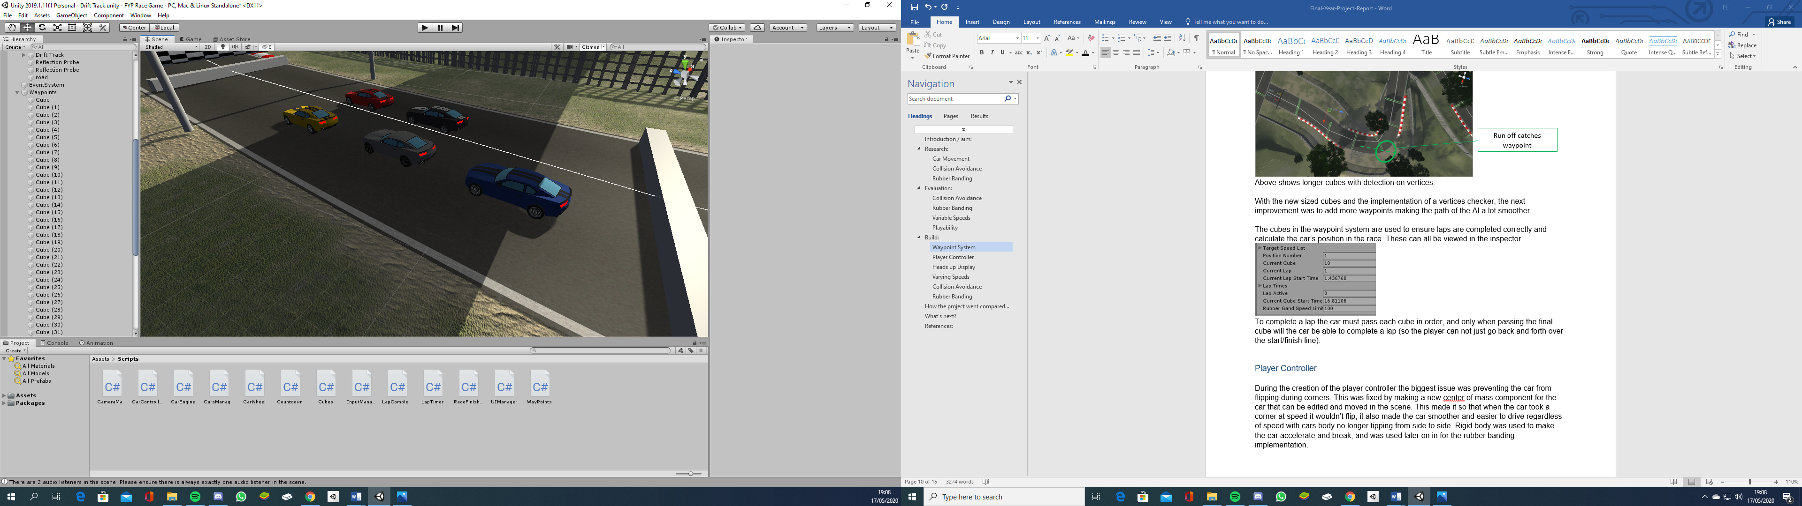

### Varying Speeds

The speed control around the track uses the same cubes that are used in the waypoints system. The AI cars brake and accelerate based on the target speed set on each individual cube. This makes it so that the AI cars can get around corners at appropriate speeds and accelerate out of the corners onto straights at high speeds.

Inspector for cube on straight (fast)

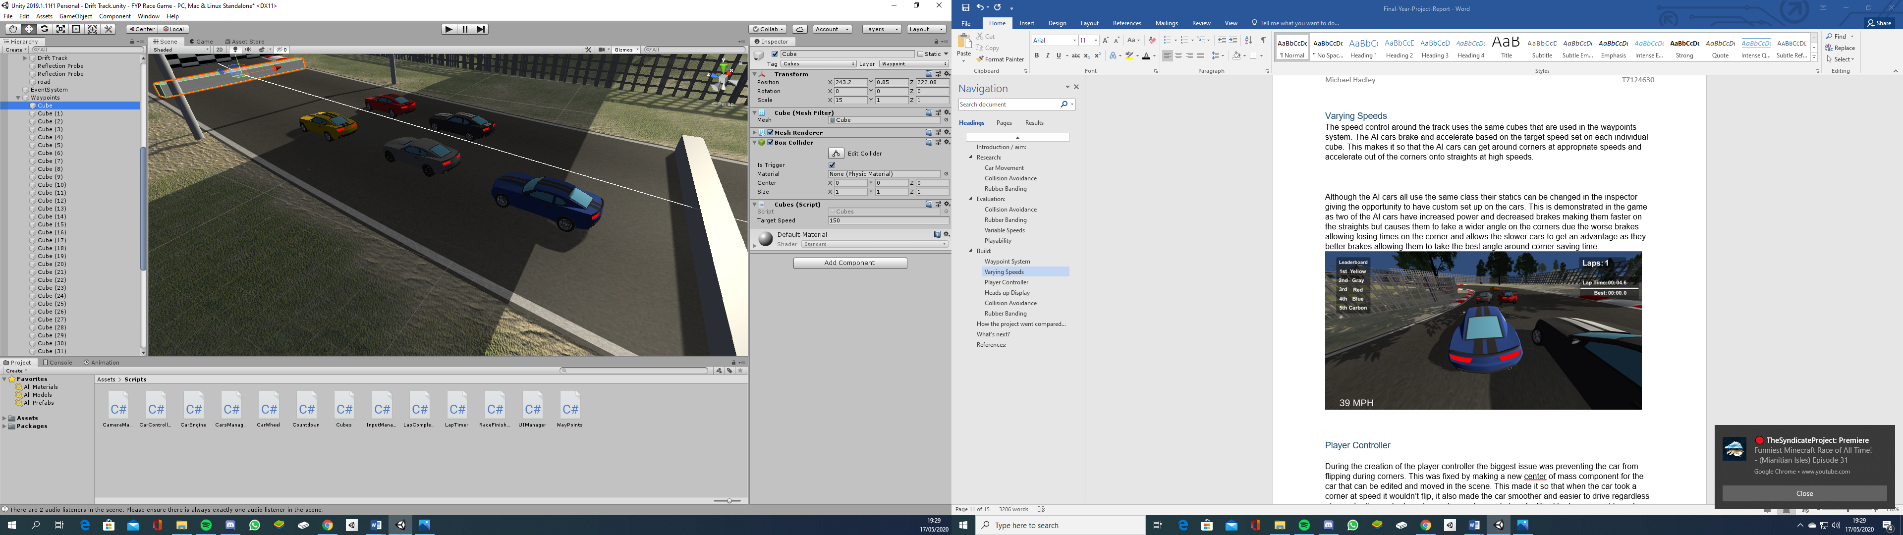

Inspector for cube on corner (slow)

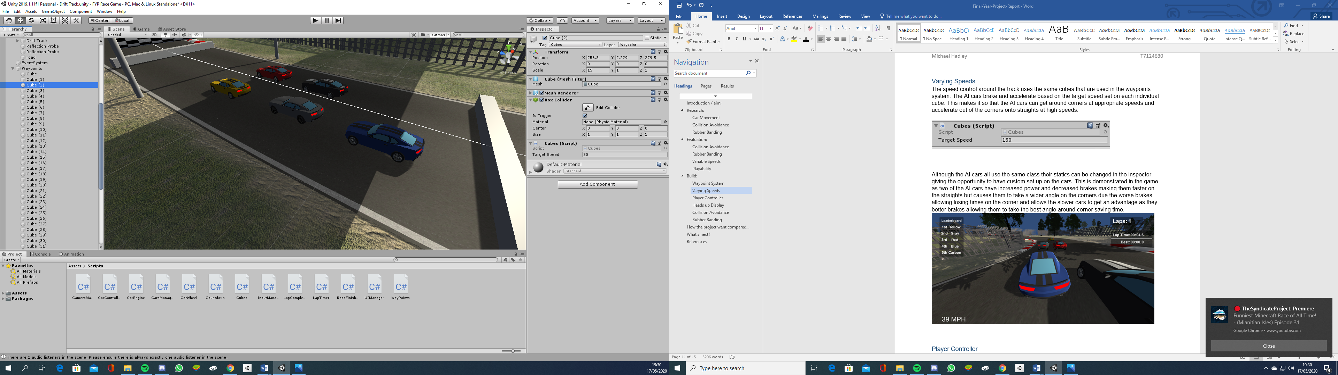

Although the AI cars all use the same class their statics can be varied in the inspector giving different performances for the different AI cars. Better brakes allows the AI cars to slow and follow the racing line around the corner, more motor torque allow the car to accelerate to the higher target speeds quicker. This resulted in different paths being taken, as below, as well as allowing overtaking.

AI cars taking different paths based on different performance values.

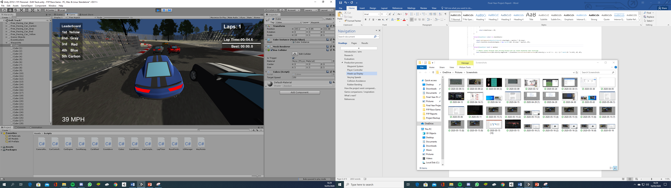

### Collision Avoidance

The collision avoidance was made using two types of checks. The first check was at the front of the car and needed to consider anything based on the full width of the car and go around the object. This was achieved using Shperecast.

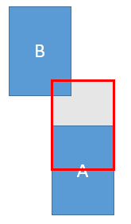

The red box shows what car A can see in front of it by using SphereCast, indicating that it can see car B, even though it is not in line with the centre of car A. The avoidance code then looked at the best route and would move car A to the right. This was tested by stopping the player car in the middle of the track ahead of the AI cars and they drive around the parked car.

The second check made was on the front wheels, pointing outwards. This did not need to consider the full width of the car just that point, so Raycast was used. Where there was an obstacle or another car close enough to the range of the wheels the car would turn away to avoid collision.

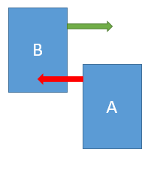

The green line shows car B’s Raycast detecting no obstacles, so car B will continue with its direction unchanged. The red line shows that the Raycast on the front wheels of A’s car which detects car B, meaning that car A will adjust its path to avoid a collision with car B. This reflects a real life situation where car B can take the racing line and car A will need to move out of the way as it is behind car B.

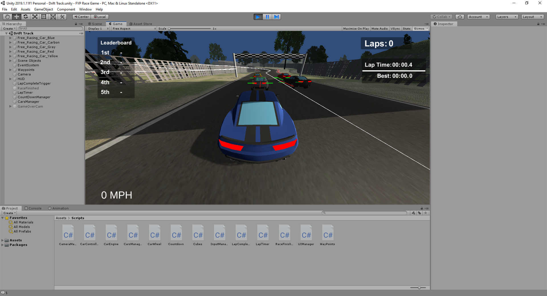

Image showing collision avoidance detection on cars. 2nd row cars show as being too close to cars in front, so have red lines going forwards.

### Rubber Banding

The rubber banding is set up so that if you or the AI are too many waypoints ahead they will have a restriction to their power slowing them down to allow players to catch up, which makes the race more competitive. Once a car has caught up the restriction is lifted from the car and both cars will race with full power.

The rubber banding system was activated based on any AI car being 5 waypoints ahead of the average waypoint, or the player being more than 5 ahead of the lead AI car. It was then deactivated once this lead had reduced to 2 waypoints. The rubber banding system ignores any cars that at the same waypoint for more than 10 seconds, allowing for crashed or stuck cars.

### Heads up Display

To make the game look more like a game than a technical exercise, a heads up display (HUD) was included. This has a lap timer, lap counter, race position, race count down and speedometer for the player’s car.

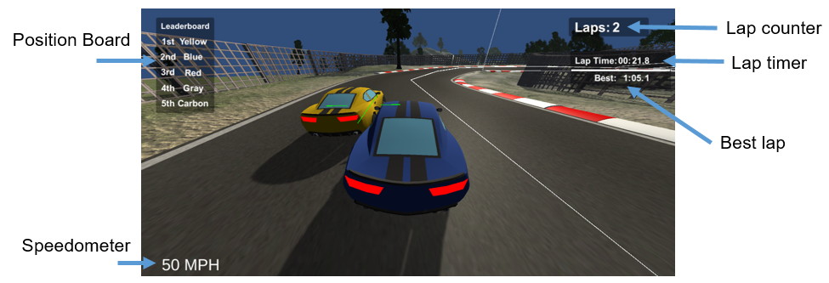

When the race starts the lap time will start to count using tenths of seconds, seconds, minutes and is displayed in the top right of the screen. The timer is reset to zero once one lap is complete as well as best lap time is displayed just under the timer.

Each time a car passes a waypoint the Position board is updated. The car calculates how many other cars are at this cube or cubes further ahead, and puts its position to that. Cars that have not reached the current cube are moved lower, and the final result is displayed. This does mean that the Position board does not update at the point of overtaking, but as there are lots of waypoints and a number of cars then this still updates frequently and the delay is not significant.

## How the project went compared to the proposal:

Overall the implementation was good with the game meeting most of the objectives. One part of the project plan that wasn’t implemented was the cars respawning onto the track if they crashed and couldn’t get back into the race. The Rubber Banding system that ignores cars that have been stuck for more than 10 seconds was able to deal with this situation and was a more realistic representation as in real races cars would not respawn. In addition passing an AI car that has flipped on to its roof adds to the enjoyment of the game. The project still runs well and answers the question with all the AI parts implemented.

Game testing was limited due to the university being closed because of the COVID-19 pandemic. The original plan was to have the game tested by a group of peers, with their comments anonymised. Instead game testing was done by my family, with verbal feedback given.

## Future development:

The game meets the objectives of the project, but there are areas that could improve as a finished product. I would like to add a soundtrack to the game as well as car audio, rather than the game being silent. A multi-player option could be added. Much of the code is already set up for this, for example the leader board loops through an array of all the players, even though at the moment there is only one. Other features which would be nice to see would be a menu system for starting and ending the game, a mini-map showing the current positions of all cars during the race, and the option to race on different tracks (the code is flexible to allow for this).

## References:

<https://www.giantbomb.com/rubber-band-ai/3015-35/> Title: Rubber Band AI.

Author: Sirkinsella98. Published Date: 03/27/20

<https://docs.unity3d.com/ScriptReference/Physics.SphereCast.html> Title: SphereCast. Author: Unity Documentation. Publication Date: 2020-05-15.

<https://docs.unity3d.com/Manual/class-WheelCollider.html> Title: Wheel Collider.

Author: Unity Documentation. Publication Date: 2020-05-15.

<https://forum.unity.com/threads/how-asymptote-slip-value-extremum-slip-value-of-the-wheel-collider.399570/> Title How: Asymptote Slip / Value, Extremum Slip / Value of the wheel collider? Author pauloaguiar. Published April 2016

<https://forum.unity.com/threads/unity-5-wheelcollider-component-is-unusable.307099/?_ga=2.187196779.234031461.1589570483-1688679482.1579248005> Title: Unity 5. WheelCollider component is unusable. Author Gaski. Published Date March 2015

<https://docs.unity3d.com/Manual/class-WheelCollider.html> Title: Wheel Collider. Author: Unity Documentation. Publication Date: 2020-05-15.

<https://forum.unity.com/threads/wheels-cause-undesired-acceleration.442501/> Title: Wheels cause undesired acceleration. Author: pauloaguiar. Published Date November 2016

1. <https://docs.unity3d.com/Manual/class-WheelCollider.html>
2. <https://docs.unity3d.com/Manual/class-WheelCollider.html>
3. <https://forum.unity.com/threads/wheels-cause-undesired-acceleration.442501/>
4. <https://forum.unity.com/threads/how-asymptote-slip-value-extremum-slip-value-of-the-wheel-collider.399570/>
5. <https://forum.unity.com/threads/unity-5-wheelcollider-component-is-unusable.307099/?_ga=2.187196779.234031461.1589570483-1688679482.1579248005>
6. <https://docs.unity3d.com/ScriptReference/Physics.SphereCast.html>
7. <https://www.giantbomb.com/rubber-band-ai/3015-35/>